

**RIGA TECHNICAL UNIVERSITY  
Faculty of Computer Science and Information Technology**

**Institute of Applied Computer Systems**

**“Data Structures Assignmnets”**

TASK OF INDIVIDUAL WORK  
**"DIP203 - Data Structures”**

**Lect, Padmaraj Nidagundi**

**Accomplished:** Said Naghiyev **Student Card No:** 201ADB100

2020./2021.

**Index**

1. Develop four algorithms to improve maths grade in school
2. Write an algorithm to find all roots of a quadratic equation ax2+bx+c=0. (write a program in c or c++/java)
3. Write an algorithm convert temperature from degree celsius to fahrenheit
4. Write an algorithm to find the largest among three different numbers entered by the user.(write a program in c or c++/java)
5. **Develop four algorithms to improve maths grade in school**

Step 0:Improve maths grade in school

Step 1:Find the Problems

Step 2:Find solution for the Problems

Step 3:Attend more classes + ask Problems to teacher + get help from parents + go to library

Step 4:Do more exams and test

Step 5:Repeat old subjects

Step 6:Find other problems + try to solve them

Step 7:Write exams

1. **Write an algorithm to find all roots of a quadratic equation ax2+bx+c=0. (write a program in c or c++/java)**

//#include<bits/stdc++.h>

#include<iostream>

#include<cmath>

using namespace std;

float a,b,c,x1,x2,realNum,imageNum,dis;

void printResult(int r){

switch(r){

case(0):

cout<<"Roots are complex!"<<endl;

cout<<"x1 = "<<realNum<<"+"<<imageNum<<"i"<<endl;

cout<<"x2 = "<<realNum<<"-"<<imageNum<<"i"<<endl;

break;

case(1):

cout<<"x = "<<x1<<endl;

cout<<endl;

cout<<a<<"*"<<x1<<"^2";

if(b>=0){

cout<<"+";

}

cout<<b<<"*"<<x1;

if(c>=0){

cout<<"+";

}

cout<<c<<" = 0"<<endl;

break;

case(2):

cout<<"x1 = "<<x1<<endl;

cout<<"x2 = "<<x2<<endl;

cout<<endl;

cout<<a<<"*"<<x1<<"^2";

if(b>=0){

cout<<"+";

}

cout<<b<<"*"<<x1;

if(c>=0){

cout<<"+";

}

cout<<c<<" = 0"<<endl;

cout<<endl;

cout<<a<<"*"<<x2<<"^2";

if(b>=0){

cout<<"+";

}

cout<<b<<"*"<<x2;

if(c>=0){

cout<<"+";

}

cout<<c<<" = 0"<<endl;

break;

}

return;

}

int main(){

cout<<"ax^2 + bx + c = 0"<<endl;

cout<<"a = ";

cin>>a;

cout<<"b = ";

cin>>b;

cout<<"c = ";

cin>>c;

dis = b*b - 4*a*c;//find Discriminant

if(dis>0){ //Discriminant has 2 roots

x1 = (-1*b + sqrt(dis))/(2*a);

x2 = (-1*b - sqrt(dis))/(2*a);

printResult(2);

}

else if(dis==0){ //Discriminant has 1 root

x1 = (-1*b + sqrt(dis))/(2*a);

printResult(1);

}

else{ //Discriminant has no real roots

realNum = (-1*b)/(2*a);

imageNum = sqrt(-1 * dis) / (2*a);

printResult(0);

}

return 0;

}

//Picture of code

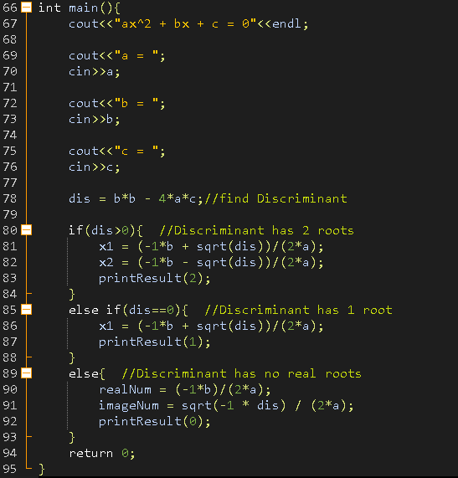

Result

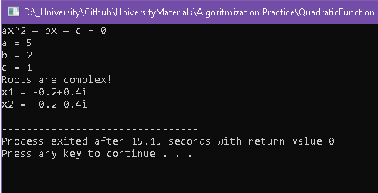

1. **Write an algorithm convert temperature from degree celsius to fahrenheit**

#include<iostream>

using namespace std;

int main(){

float c;

cout<<"input C"<<endl;

cin>>c;

cout<<"fahrenheit:"<<endl;

cout<<(c*9/5)+32<<" F"<<endl;

return 0;

}

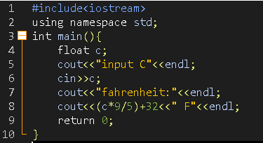

Result:

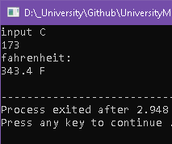

1. **Write an algorithm to find the largest among three different numbers entered by the user.(write a program in c or c++/java)**

#include<iostream>

using namespace std;

int main(){

float a,b,c;

cout<<"enter 3 number"<<endl;

cin>>a>>b>>c;

cout<<max(a,max(b,c))<<endl;

return 0;

}

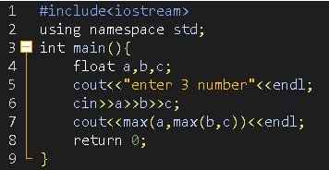

Result:

